**Jenkins Pipeline Options and Use Cases:**

Jenkins Pipeline Parallel executions

1. Install Plugin pipeline parallel
2. Open Pipeline Syntax Generator and Search for “parallel: Execute in parallel”

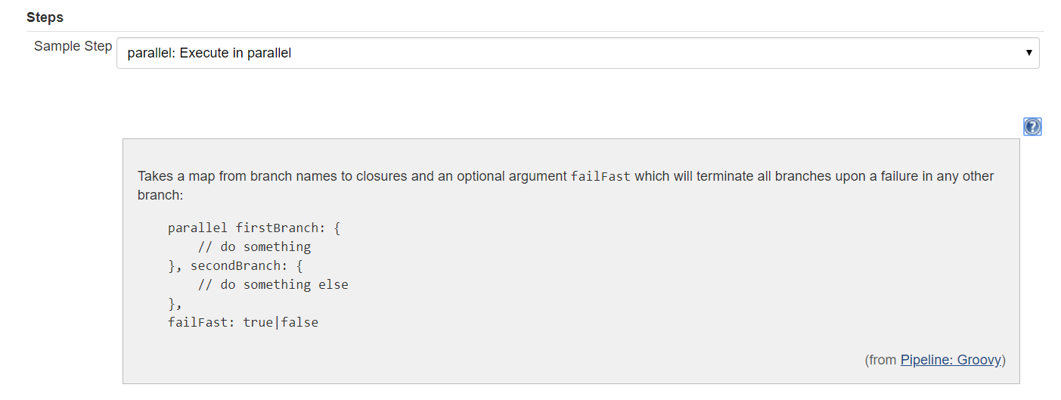

failFast: true :> if any of the stages fails it comes out of it

1. Create a Pipeline Job: You can parallel stages, In the below demo I have shown you how to execute package and install stages in parallel.

In real world we can execute any stages in parallel for example.

1. Unit test and integration test in parallel
2. Deploy packages/artifacts to 2 different system (VM/Docker etc) in parallel
3. API test and unit test in parallel

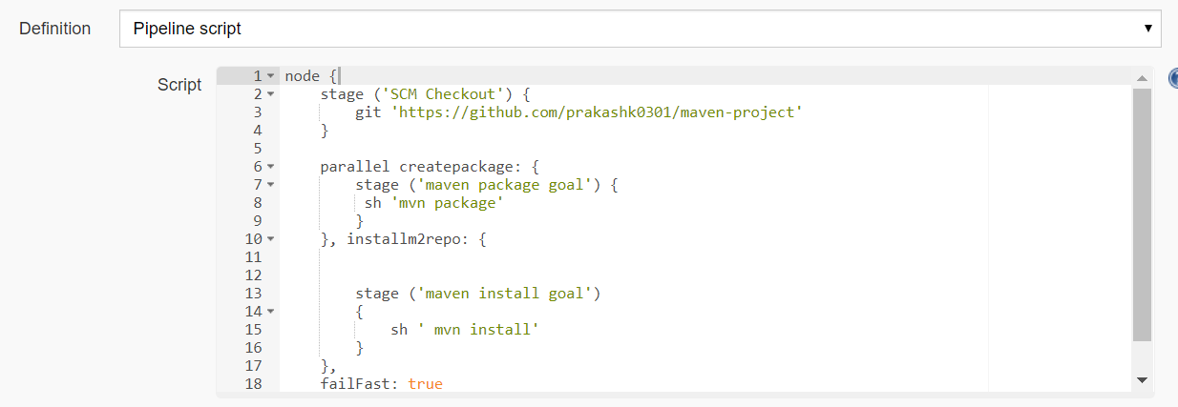

node {

stage ('SCM Checkout') {

git 'https://github.com/prakashk0301/maven-project'

}

parallel createpackage: {

stage ('maven package goal') {

sh 'mvn package'

}

}, installm2repo: {

stage ('maven install goal')

{

sh ' mvn install'

}

},

failFast: true

}

Some more examples:

node {

parallel firstbranch: {

stage ('scm checkout master') {

git url: 'https://github.com/prakashk0301/maven-project', branch: 'master'

}

}, secondbranch: {

stage ('scm checkout ci-cd-pipeline')

{

git url: 'https://github.com/prakashk0301/maven-project', branch: 'ci-cd-pipeline'

}

},

failFast: true

}

# How to execute the same job in parallel

(Concurrent builds:

**Problem Statement:** Sometimes we have to execute same job in parallel but by default Jenkins doesn’t allow concurrent builds. If we click on build now, build will be in pending state until previous job executed successfully. So we have to wait a long.

This problem can be resolve if we allow Jenkins to execute concurrent builds.

**Solution:** Select Execute concurrent builds if necessary.

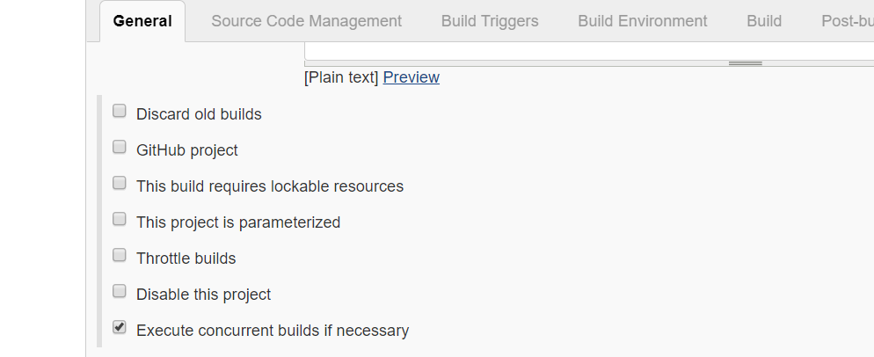

Multi Branch Pipeline:

The **Multibranch Pipeline** project type enables you to implement different Jenkinsfiles for different branches of the same project. In a Multibranch Pipeline project, Jenkins automatically discovers, manages and executes Pipelines for branches which contain a Jenkinsfile in source control.

This eliminates the need for manual Pipeline creation and management.

Step 1. Install plugin: [Pipeline: Multibranch with defaults](https://plugins.jenkins.io/pipeline-multibranch-defaults)

Step 2: Create a new multi branch pipeline job.

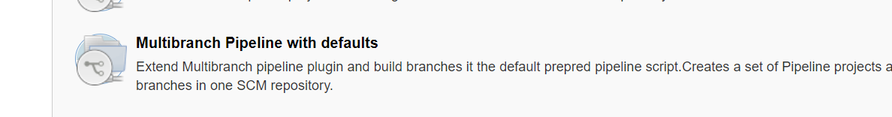

Step 3: Then provide Project code URL.

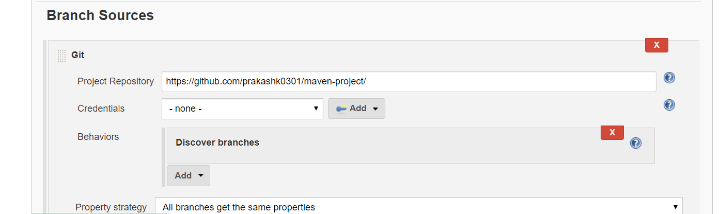

Step 4: It will automatically discover all the branch.

Restart Policies In Jenkins:

Method 1: Safe restart pluing can also be used to restart jenkins

Method 2:

(jenkins_url)/safeRestart - Allows all running jobs to complete. New jobs will remain in the queue to run after the restart is complete.

(jenkins_url)/restart - Forces a restart without waiting for builds to complete.

<https://support.cloudbees.com/hc/en-us/articles/216118748-How-to-Start-Stop-or-Restart-your-Instance->